|  |  |
| --- | --- |
| School of Electronic Engineering and Computer Science | **Interim Report**  **Programme of Study:**  BSc Computer Science  **Project Title:**  **SmartFit – *Losing weight, the smart way***  **Supervisor:**  Thomas Roelleke  **Student Name:**  Muhammed Ismael Ali  Date: 23/11/2020 |
| Final Year  Undergraduate Project 2020/21 |
| QMLogo |

Abstract

This project conveys the development of an android application, ‘SmartFit’ that is aimed to help those that have made their initial step into the world of diet & fitness whilst also aiming to entice those that are already a part of it however lack the motivation needed to continue. The application, SmartFit allows users to track calories they have lost throughout the day using a counter which keeps users updated & recommends further activities to help the user reach their calorie burning goals. It also implements additional features that will be beneficial to users in achieving weight loss or maintaining a weight. SmartFit also incorporates these features with elements of gamification, one of such is in the form of attainable rewards such as badges that will be rewarded to users to give a sense of accomplishment & provide the motivation that they may lack. The application also implements automatic health tracking through the use of the device’s built-in accelerometer to calculate activities such as the number of steps taken by the user to provide users with accurate data to assist with their calorie burning endeavours.

This report covers an in-depth overview of the process carried out to create the application, SmartFit. It will also provide explanations & justifications on the research that has been carried out as well as the methodologies that have been used throughout the development process.

**C**

**ontents**

Chapter 1: Introduction 5

*1.1 Background 5*

*1.2 Problem Statement 5*

*1.3 Aim 6*

*1.4 Objectives 6*

*1.5 Research Questions 7*

*1.6 Report Structure 7*

Chapter 2: Literature Review 8

*2.1 Literature Review 8*

*2.2 Existing Applications Review 11*

*2.3 Proposed Solution 13*

Chapter 3: Requirements Analysis & Design 14

Chapter 4: Presentation 15

4.1 *Source Code* 15

Chapter 5: Evaluation 16

Chapter 6: Conclusion 17

References 18

Appendix A – Risk Assessment 19

Appendix B – Revised Project Time Plan 22

# Introduction

## Background

Diet & fitness is a major player when it comes to maintaining a successful and healthy lifestyle as a good diet & regular fitness is the fuel your body needs to operate and maintain itself. A lifestyle consisting of a bad diet & limited exercise is comparable to the effects of using the wrong engine oil on your car as the car will begin to have many problems eventually leading to it breaking down. In this case the car is your body and the engine oil is the fitness & diet you provide it. In this modern society, diet & fitness are often overlooked as the majority of people are focussed on different aspects of their lives. Many studies show that regular fitness & a good diet can provide a multitude of health benefits whilst also proving to solve a number of daily problems that people experience. It is said that exercise is a natural anti-anxiety treatment whilst also being as effective as an anti-depressant pill (Robinson, L., 2020). In addition to this, it is also reported that the consumption of the right foods complemented by the appropriate amount of exercise can even boost the bodies natural ability to fight many diseases (Revere Health, 2017).

As we are living in an era where technology has seemed to take over our daily lives with the large number of people possessing a hand-held device, a way to reach out to people and engage them in a healthy lifestyle is through the development of an engaging diet & fitness app, so they can reap the many benefits that is brought about through diet & fitness.

## Problem Statement

An issue with current existing diet & fitness applications such as MyFitnessPal is that tracking is not carried out in a very user-friendly way, be it tracking calories or tracking other progress. Users that want to get into fitness with the use of applications are not provided with a clear guideline on their progress and what they can do to reach their tracking goals. Furthermore, a lot of current applications focus on tracking the calories consumed however do not focus on the aspect of calories burnt/lost. Many people like myself want the ability to set & track calories that are being lost throughout the day through doing activities however this is currently not present in a lot of applications.

Another problem that can be identified is the lack of motivation that people have once they set health and fitness goals. It is said that the initial motivation is the start of a journey however it does not last long if there is nothing to keep you going (Alexandra Parren, 2020). Existing applications though do provide the functionalities to help aid a person’s diet & fitness journey, these applications have a very monotonous and non-user-friendly way of applying these functionalities meaning users often become disengaged with the application once the initial motivation has faded.

## Aim

This project is aimed to develop an android application for diet & fitness called SmartFit that can easily be used by anyone that wants to begin leading a healthy lifestyle, or those that want to maintain it. The application will aim to implement features that will make the application engaging and user-friendly.

* The core aim of SmartFit is to implement a counter which tracks the number of calories a user has burnt in comparison to the goal they have set and provide recommendations to help users reach the goal through notifications throughout the day.
* In order for the core functionality to work, SmartFit will also allow users to record fitness activities. Users will then be able to compare & compete with other users (Friends or family) on the platform with recorded activities.
* Another important aim of SmartFit is to provide a very simple user-friendly & engaging interface to users so they are able to navigate the app and use the intended functionalities without being overwhelmed by large amounts of unnecessary information.
* SmartFit will also implement gamification elements with intentions of enticing users and keeping them motivated. The main gamification feature that SmartFit is aiming to implement is a reward system that will reward users with badges when they earn certain amounts of points which are accumulated by completing ‘step’ milestones that will be tracked by the device’s built in accelerometer. This reward system is used to help keep users of the app motivated by providing a sense of accomplishment through collecting badges. It is also used as a means to aid users with their daily fitness by providing users with an activity that rewards them.
* SmartFit will also provide functionalities such as the calculation of the user’s BMI & providing them information regarding the nutrients/macronutrients they need to consume to either maintain or lose weight.

## Objectives

* To investigate current existing health & fitness applications available to users
* Research the process & algorithms required to implement intended features
* Produce an effective design & user-friendly layout of the application that is easily navigable by users
* To develop an android application that incorporates the design & functionalities discussed, using algorithms researched
* To perform user testing once application has been developed to conclude effectiveness of the application
* Utilise results produced from user testing to produce an evaluation of the application

## Research Questions

The following research questions were explored:

* What effects does gamification have on applications, specifically in the health & fitness domain?

## Report Structure

**Chapter 1:** This chapter will include an introduction & background to my project and provide reasonings to why I have decided to undergo this project and what I aim to achieve.

**Chapter 2:** This chapter will detail the research that has been undergone to formulate solutions needed to develop my application.

**Chapter 3:** This chapter will cover a requirement analysis of my project; it will include things such as the functional and non-functional requirements of my project. It will also provide a design prototype of my application that I will work towards implementing into a fully functional android application.

**Chapter 4:** This part of the report will explain the implementation process of my project, how & what has been implemented based on the initial aims.

# Literature Review

## Literature Review

### The Effects Of Gamification & How It Can Be Used In Health & Fitness Applications

Gamification has been defined as the use of game design elements in a non-game context to make tasks less monotonous and more playful (Kappen & Orji, 2017). Gamified systems tend to use gaming elements interchangeably with the overall design of the system it is being incorporated into, where the overall objective is to foster fun, commitments and goals, eventually leading to an increase in the motivation of the users who use such systems as tasks & routines become less of a chore and more of a recreation (Kappen & Orji, 2017).

Gamification in mobile applications has become a popular strategy to influence behaviour of consumers over the years (Lister, et al., 2014). According to Kappen & Orji (2017) within the health & fitness domain there are many gamification techniques and elements that can be employed to create motivational mechanisms for users, one such element is the use of a reward system. Rewards are given in recognition of an achievement or effort; it is the most commonly used gamification technique by designers. These rewards can be classified as either intrinsic or extrinsic where extrinsic rewards include things such as badges, points or even money and intrinsic rewards on the other hand are psychological rewards such as personal fulfilment from completing a goal or gaining a new skill etc. Goal setting is another gamification technique highlighted by Kappen & Orji (2017) that should be considered as by providing users with the ability to set goals it helps motivate behaviour by challenging users to reach the goals they set. Other techniques that were also mentioned by Kappen & Orji (2017) are the use of challenges that could be provided to users through manageable tasks or incremental challenges, also creating a competitive environment as in this day and age many people tend to be competitive.

The effects of gamification on health and fitness has seen a positive response according to Vicente, et al. (2014). A campaign was carried out by an e-commerce company called NextJump, led by the director, Charlie Kim where the director had installed multiple gyms in the company’s offices as well as created an app that rewarded employees that had made visits to these gyms regularly (Vicente, et al., 2014). With this initial campaign a figure of 12% was recorded, of staff who had started exercising regularly. This figure further increased to a staggering 70% as more gamification features were implemented (Vicente, et al., 2014).

### Machine Learning

Machine learning (ML) is a subset of artificial intelligence (AI) that provides systems with the ability to learn and improve from experience without being explicitly programmed. The way this process works is that the system is provided with some form of initial data based on real world scenarios, the system then uses this data to solve or provide solutions to problems associated with the scenario it has been modelled after. Machines learn through the provision of algorithms, these algorithms are classified into 4 different categories based on the learning approach; supervised learning, unsupervised learning, semi-supervised learning & reinforcement learning (Portugal, [Alencar](https://scholar.google.com/citations?user=0xzfYjwAAAAJ&hl=en&oi=sra) & Cowan, 2018).

The most common type of ML algorithms used in recommendation systems are based on supervised learning. Supervised learning is when the system is provided with a set of “training data” it uses this training data to learn and apply the knowledge it gains on real data (Portugal, [Alencar](https://scholar.google.com/citations?user=0xzfYjwAAAAJ&hl=en&oi=sra) & Cowan, 2018). Unsupervised learning on the other hand is focussed on finding patterns in the data (Portugal, [Alencar](https://scholar.google.com/citations?user=0xzfYjwAAAAJ&hl=en&oi=sra) & Cowan, 2018). Semi-supervised learning is when the system is provided with data however some parts of the data are missing or not present therefore the system still has to learn as it is not provided with the full set of data unlike supervised learning (Portugal, [Alencar](https://scholar.google.com/citations?user=0xzfYjwAAAAJ&hl=en&oi=sra) & Cowan, 2018). Finally, reinforcement learning is based on external feedback by either a thinking entity or environment for example, if a dog was told to sit down or jump and they performed the action correctly they would receive a cookie which would be considered positive feedback or if they did not perform the action correctly they would not receive a cookie which would be considered as negative feedback (Portugal, [Alencar](https://scholar.google.com/citations?user=0xzfYjwAAAAJ&hl=en&oi=sra) & Cowan, 2018). This feedback is then used make future predictions; this is known as reinforcement learning.

### Algorithms

For my project I will be integrating ML to achieve some of the requirements that have been discussed. For example, for the notifications that will be provided by my application for recommendations, the application will have to figure out whether a notification should be sent to the user or not as to not bombard the user. In order to achieve this, I will have to incorporate a ML algorithm that will be able to determine the importance of sending a notification to the user. Another example is using a ML algorithm to determine what should be recommended to the user based on how many calories they have left to burn. I have therefore researched a few ML algorithms that could be useful to my project.

#### K-NN Algorithm

K-NN or K-nearest neighbour is commonly used as a classification algorithm to determine the class of an input nearest to its K neighbours (Srivastava, 2018). This algorithm is a supervised ML algorithm that relies on labelled input data to learn from.

The way the algorithm works is it determines the class of the given input by calculating the distance to other K amount of inputs that are already classified.

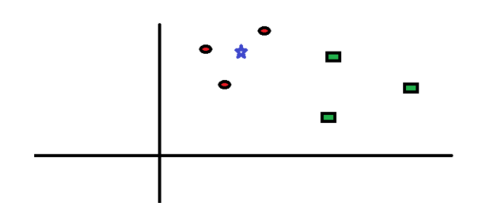

For example, in the figure above, we have two classified groups of data the ‘red circle (RC)’ and the ‘green square (GS)’suppose a new input has been given to a system which is represented as the ‘blue star (BS)’ in the figure above. How does the system classify this data?

We have to set a value of K which is used as a parameter that refers to the number of nearest neighbours to include when the new input is being classified. Suppose for the example above we set the value K = 3, we can see that the 3 closest neighbours to the BS are the RC as the majority, hence the BS will be classified as a RC (Srivastava, 2018). This distance from the new input and nearest neighbours is calculated using many different distance formulas the common being ‘Euclidean’s distance’ formula.

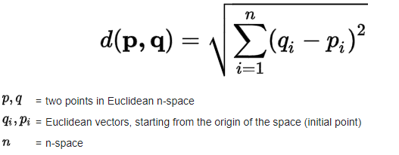

#### Naïve Bayes Algorithm

Naïve bayes is a classification technique based on the Bayes theorem. (Ray, 2017) It is a probabilistic ML model that’s used for classification. It is known as ‘naïve’ bayes as it assumes the presence of a feature of a particular class is independent to other features. An example would be if we had a class which determined whether we played tennis or not based on the features; temp, humidity & wind. Temp would not be related to humidity or wind and vice versa (Ray, 2017).

Bayes theorem allows us to calculate the probability of an event happening given another event has already transpired. Using this theorem, we are able to construct a formula which allows us to predict the classification of a new class that a machine is given.

**p(class|features) = [p(features|class) * p(class)] / p(features)**

The above formula is used to determine the classification of a new class based on the features the machine has already been fed which is known as the training data.

## Existing Applications Review

Currently there are many diet & fitness applications available on the market. From these existing applications I will examine a few of the top-rated applications to discover flaws or features that I could incorporate into my application to make it more user-friendly and useful.

### MyFitnessPal



MyFitnessPal is a smartphone application both available on the android and IOS. This application was designed to help users keep track of their diets & exercise. The application provides a range of features which includes a progress graph that shows the visual progress of an individual’s weight. A diary where users can keep track of their daily calorie intake. Workout routines with videos. A recipe journal consisting of a wide variety of recipes and a lot more. MyFitnessPal also incorporates one of the best food databases in the app market that allows users to search up a wide range of food for its macronutrients & calories. The application though primarily is a free to use application it also comes with a subscription-based model that provides additional functionalities for the user for example macronutrients of a food when searched are only provided if the user has a premium subscription with the app. MyFitnessPal also implements gamification features to help motivate users for example progress bars are provided to users to show the progress made towards their weight goal.

### Lose It!



Lose It! is an application available on both android and IOS. The application focusses on setting custom goals and helps you achieve those goals. The application also provides a variety of personalised features including the ability to set custom reminders, the ability to create custom workout routines to the optional addition of automatic tracking via the use of external devices and much more. Lose It! also has its own community portal where users can share their weight loss journeys with each other to help keep them motivated. Lose It! like MyFitnessPal also comes with a subscription-based model where many features are locked behind a premium tier.

### FatSecret



FatSecret is another android/IOS application available currently on the market that allows users to track their nutrition, weight & exercise. This application like the others provide the same basic functionalities for tracking such as a diary to track calorie intake, a graph showing visual weight progress and many more. The uniqueness of this app is presented in the form of being able to use a calendar and plan out meals in advance. Furthermore, unlike the two previously reviewed applications, FatSecret provides a very simplistic layout that is very user-friendly and visually pleasing.

Following the review of these three applications I have further reviewed another two applications however I noticed to that the applications integrate the same basic functionalities therefore I did not document them.

### Summary

|  |  |  |
| --- | --- | --- |
| **Name Of Application** | **Core Features Provided By Application** | **Drawbacks Identified** |
| MyFitnessPal | * Calorie tracking * Visual weight loss progress via the use of graphs/charts * Community portal * Automatic health tracking | * Cluttered UI * Features locked behind a premium subscription * No recommendations provided to aid a user with goals * No feature to set daily goals |
| Lose It! | * Calorie tracking * Custom reminders * Community portal * Reward system (Use of badges) * Automatic health tracking | * No recommendations provided to aid a user with goals * Features locked behind a premium subscription |
| FatSecret | * Calorie tracking * Diet calendar (Plan in advance | * No recommendations provided to aid a user with goals * No feature to set daily goals * Lacklustre, no features to make app engaging |

## Proposed Solution

The programming language I will be using to develop my application is ‘Python’ as this is a language that has access to wide variety of ML libraries that I can use to implement the ML functionalities to my application.

I will be developing my program on ‘Kivy’ which is a free open source framework for python that is used to develop mobile applications (IOS, Android).

I will also be using ‘Firebase’ which is a Google back-end app development software. It provides a NoSQL database that allows you to store and sync data between users in real-time. I will be using this database to store information associated to users of my system.

# Requirements Analysis & Design

# Presentation

## Source Code

static public void main(String[] args) {

try {

UIManager.setLookAndFeel(UIManager.getSystemLookAndFeelClassName());

}

catch(Exception e) {

e.printStackTrace();

}

new WelcomeApp();

}

# Evaluation

# Conclusion

References

1. *Robinson, L., 2020. The Mental Health Benefits Of Exercise - Helpguide.Org. [online] Helpguide.org. Available at: <https://www.helpguide.org/articles/healthy-living/the-mental-health-benefits-of-exercise.htm> [Accessed 20th October 2020].*
2. *Revere Health. 2017. Healthy Living: The Importance Of Diet And Exercise - Revere Health. [online] Available at: <https://reverehealth.com/live-better/healthy-living-importance-diet-exercise/> [Accessed 20th October 2020].*
3. *Sundried Activewear. 2020. Research Shows 43% Of People Expect To Give Up Their New Year's Resolutions By February. [online] Available at: <https://www.sundried.com/blogs/training/research-shows-43-of-people-expect-to-give-up-their-new-year-s-resolutions-by-february> [Accessed 20th October 2020].*
4. *Kappen, D. and Orji, R., 2017. Gamified and persuasive systems as behaviour change agents for health and wellness. XRDS: Crossroads, The ACM Magazine for Students, 24(1), pp.52-55.*
5. *Lister, C., West, J., Cannon, B., Sax, T. and Brodegard, D., 2014. Just a Fad? Gamification in Health and Fitness Apps. JMIR Serious Games, 2(2), p.e9.*
6. *Oliver Vicente, Sandra Vicente, Daniel Martin, Miguel Angel Rodriguez-Florido, and Manuel Maynar. 2014. Health gamification. In Proceedings of the 2014 Summer Simulation Multiconference (SummerSim '14). Society for Computer Simulation International, San Diego, CA, USA, Article 57, 1–7.*
7. *Portugal, I., Alencar, P. and Cowan, D., 2018. The use of machine learning algorithms in recommender systems: A systematic review. Expert Systems with Applications, 97, pp.205-227.*
8. *Srivastava, T., 2018. K Nearest Neighbour | KNN Algorithm | KNN In Python & R. [online] Analytics Vidhya. Available at: <https://www.analyticsvidhya.com/blog/2018/03/introduction-k-neighbours-algorithm-clustering/> [Accessed 15th November 2020].*
9. *Ray, S., 2017. Learn Naive Bayes Algorithm | Naive Bayes Classifier Examples. [online] Analytics Vidhya. Available at: <https://www.analyticsvidhya.com/blog/2017/09/naive-bayes-explained/> [Accessed 19th November 2020].*

Appendix A – Risk Assessment

|  |  |  |  |  |
| --- | --- | --- | --- | --- |
| **Description Of Risk** | **Description Of Impact** | **Likelihood Rating** | **Impact Rating** | **Preventative Actions** |
| Corruption of work/work being deleted or lost | Nothing to submit resulting in a fail | Low | High | Always create a backup copy of the project work. For the documented report, services such as google drive can be used to upload and keep my work safe and secure or the use of external storage drive such as a USB can be used. For the program services such as GitHub can be used to ensure the program is stored securely even if something was to happen to my computer. |
| Falling ill/health issues | This will result in less work being completed as well as throw off the project time plan. Also, if the illness occurs near deadlines it will lead to delayed submissions | Medium | High | Ensure I am on top of the project work and sticking closely or ahead of the project time plan to handle unforeseen events such as falling ill. In addition to this, maintaining my health should be a top tier priority especially since we are experiencing a pandemic. |
| Neglecting project work due to assignments from other modules | This will lead to an inability and struggle to meet deadlines as the project work will be piled up | Low | High | Create a timetable to divide the work load, making sure I am not behind on any lectures for other modules as this will consume/cut into project working hours. |
| Incorrect implementation of features | If a feature is not implemented correctly it will need to be revised which will cut into hours that can be used elsewhere | Medium | Medium | Research on the implementation methods for the different features thoroughly before attempting to program them. |

|  |  |  |  |  |
| --- | --- | --- | --- | --- |
| Unable to access desired resources | Will result in the inability to create the intended feature/functionality that needed to access the desired resource | Low | High | Ensure thorough research has been carried out on the types of resources that will be used for the project and check if they are accessible. |
| Android software update | If a new software update rolls through whilst creating the application certain features may not work as intended or will need to be revised | Low | Medium | Keep software up to date when testing application on android devices, try to minimise reliance on android features |

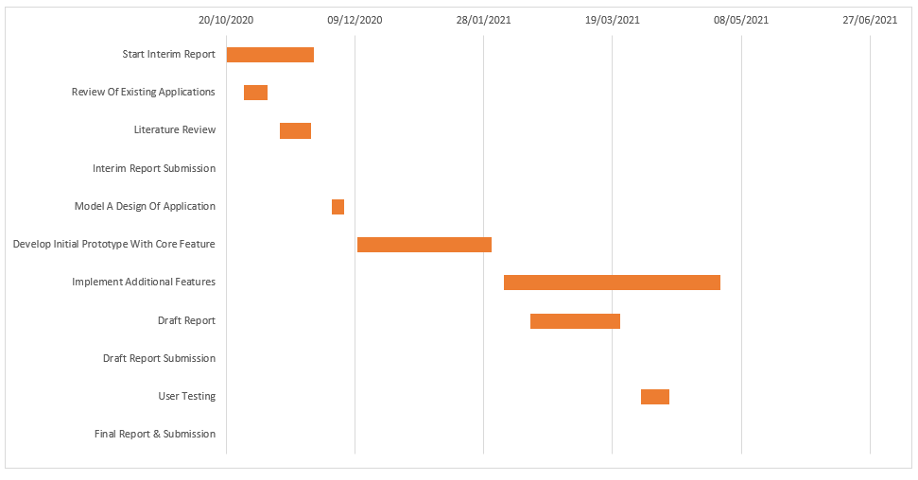Appendix B – Revised Project Time Plan